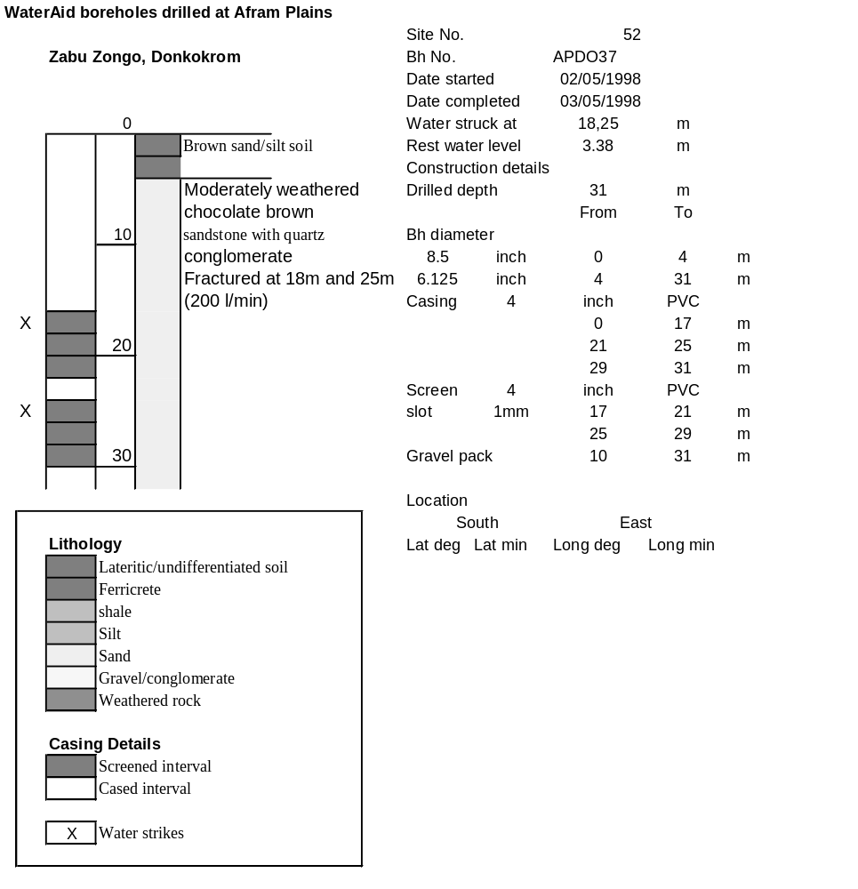

Ghana | Test pumping
Borehole No. |  | APDO37
Hole No |  | 52 |  | (2)
Village |  | Donkorkrom
Date |  | 20/11/1998
Point above GL |  | 0.67 | m
Pump depth |  | 16 | m
SWL |  | 4.05 | m
Start Time |  | 08:21
Drawdown test |  |  |  |  | Recovery Test
time | pwl (m) | Q l/min | dd | sc(q/s) | Time | wl (m) | t/t' | Resdd
0.00 | 4.05 | 120.00 | 0.00 |  | 0.00 | 9.06 |  | 5.01
1.00 | 6.20 | 120.00 | 2.15 | 55.81 | 1.00 | 6.80 | 241.00 | 2.75
2.00 | 6.43 | 120.00 | 2.38 | 50.42 | 2.00 | 6.60 | 121.00 | 2.55
3.00 | 6.57 | 120.00 | 2.52 | 47.62 | 3.00 | 6.50 | 81.00 | 2.45
4.00 | 6.67 | 120.00 | 2.62 | 45.80 | 4.00 | 6.44 | 61.00 | 2.39
5.00 | 6.74 | 120.00 | 2.69 | 44.61 | 5.00 | 6.40 | 49.00 | 2.35
6.00 | 6.79 | 120.00 | 2.74 | 43.80 | 6.00 | 6.35 | 41.00 | 2.30
7.00 | 6.84 | 120.00 | 2.79 | 43.01 | 7.00 | 6.32 | 35.29 | 2.27
8.00 | 6.88 | 120.00 | 2.83 | 42.40 | 8.00 | 6.29 | 31.00 | 2.24
9.00 | 6.92 | 120.00 | 2.87 | 41.81 | 9.00 | 6.26 | 27.67 | 2.21
10.00 | 6.96 | 120.00 | 2.91 | 41.24 | 10.00 | 6.22 | 25.00 | 2.17
12.00 | 7.02 | 120.00 | 2.97 | 40.40 | 12.00 | 6.18 | 21.00 | 2.13
14.00 | 7.08 | 120.00 | 3.03 | 39.60 | 14.00 | 6.14 | 18.14 | 2.09
16.00 | 7.13 | 120.00 | 3.08 | 38.96 | 16.00 | 6.10 | 16.00 | 2.05
18.00 | 7.17 | 120.00 | 3.12 | 38.46 | 18.00 | 6.07 | 14.33 | 2.02
20.00 | 7.22 | 120.00 | 3.17 | 37.85 | 20.00 | 6.04 | 13.00 | 1.99
25.00 | 7.31 | 120.00 | 3.26 | 36.81 | 25.00 | 5.98 | 10.60 | 1.93
30.00 | 7.40 | 120.00 | 3.35 | 35.82 | 30.00 | 5.93 | 9.00 | 1.88
35.00 | 7.47 | 120.00 | 3.42 | 35.09 | 35.00 | 5.88 | 7.86 | 1.83
40.00 | 7.54 | 120.00 | 3.49 | 34.38 | 40.00 | 5.84 | 7.00 | 1.79
45.00 | 7.60 | 120.00 | 3.55 | 33.80 | 45.00 | 5.81 | 6.33 | 1.76
50.00 | 7.66 | 120.00 | 3.61 | 33.24 | 50.00 | 5.78 | 5.80 | 1.73
55.00 | 7.71 | 120.00 | 3.66 | 32.79 | 55.00 | 5.75 | 5.36 | 1.70
60.00 | 7.77 | 120.00 | 3.72 | 32.26 | 60.00 | 5.72 | 5.00 | 1.67
70.00 | 7.76 | 120.00 | 3.71 | 32.35 | 70.00 | 5.68 | 4.43 | 1.63
80.00 | 7.97 | 120.00 | 3.92 | 30.61 | 80.00 | 5.64 | 4.00 | 1.59
90.00 | 8.05 | 120.00 | 4.00 | 30.00 | 90.00 | 5.61 | 3.67 | 1.56
100.00 | 8.13 | 120.00 | 4.08 | 29.41 | 100.00 | 5.59 | 3.40 | 1.54
110.00 | 8.22 | 120.00 | 4.17 | 28.78 | 110.00 | 5.56 | 3.18 | 1.51
120.00 | 8.29 | 120.00 | 4.24 | 28.30 | 120.00 | 5.54 | 3.00 | 1.49
130.00 | 8.36 | 120.00 | 4.31 | 27.84
140.00 | 8.44 | 120.00 | 4.39 | 27.33
150.00 | 8.51 | 120.00 | 4.46 | 26.91
160.00 | 8.59 | 120.00 | 4.54 | 26.43
170.00 | 8.64 | 120.00 | 4.59 | 26.14
180.00 | 8.71 | 120.00 | 4.66 | 25.75
190.00 | 8.78 | 120.00 | 4.73 | 25.37
200.00 | 8.83 | 120.00 | 4.78 | 25.10
210.00 | 8.89 | 120.00 | 4.84 | 24.79
220.00 | 8.95 | 120.00 | 4.90 | 24.49
230.00 | 9.00 | 120.00 | 4.95 | 24.24
240.00 | 9.06 | 120.00 | 5.01 | 23.95

